**1. Create an array of two 3×3 matrices and extract specific elements**

OUTPUT:

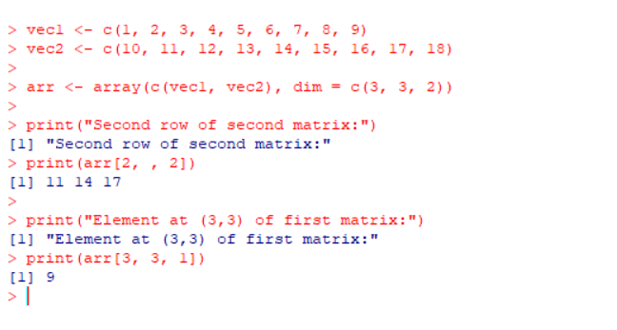

**2. Create an array using four given columns, three given rows, and two given tables**

Output:

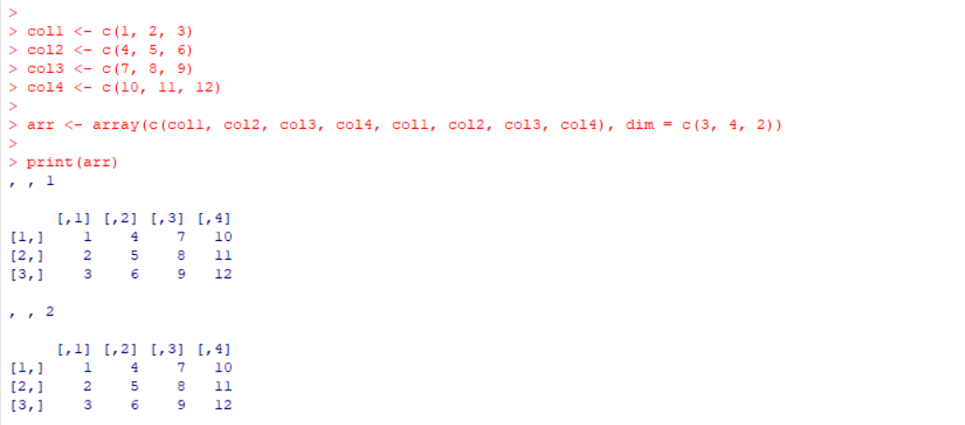

**3. Create a factor for the height of women from the**women**dataset**

Output:

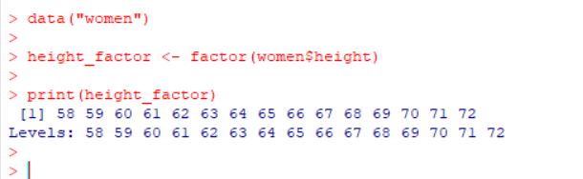

**4. Extract five levels from a random sample of**LETTERS.

Output:

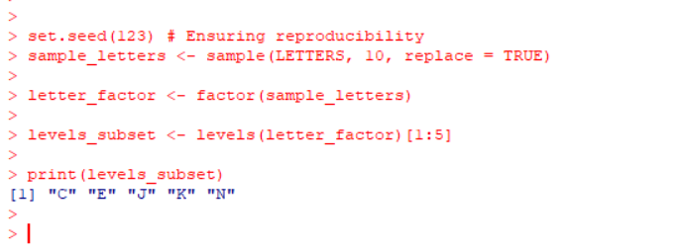

**5. Perform EDA on the iris dataset**

**Output:**

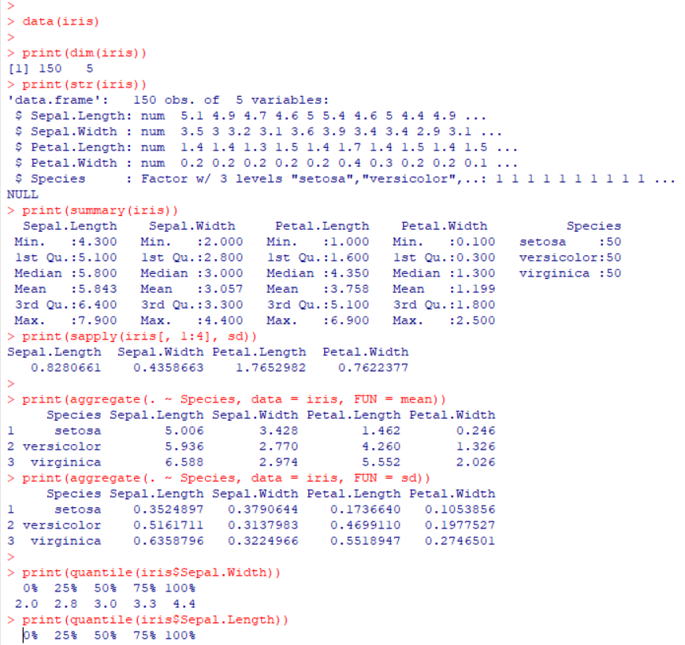 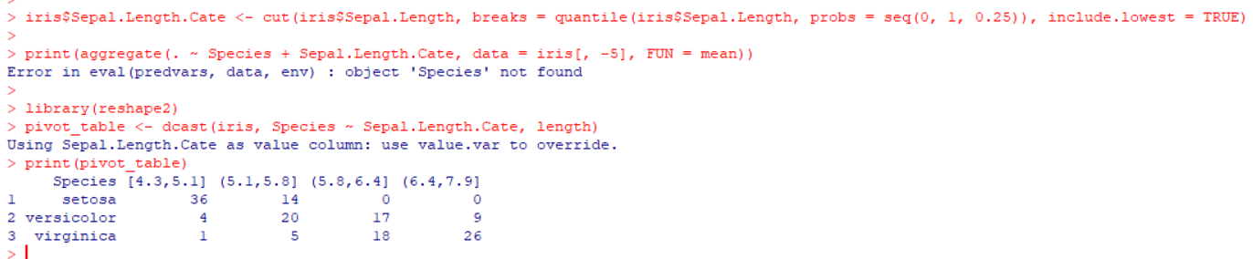

**6. Logistic Regression with iris dataset (80% Train, 20% Test)**

**Output:**

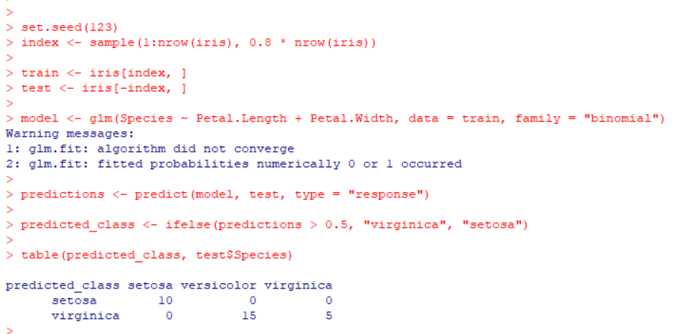

**7. Explore airquality dataset**

**Output:**

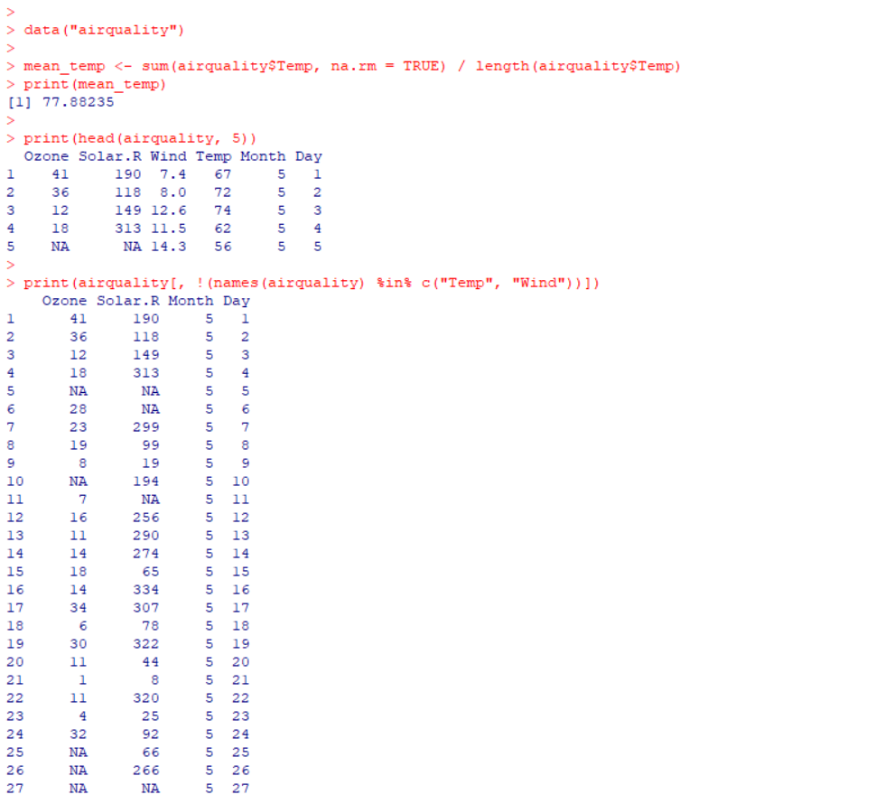 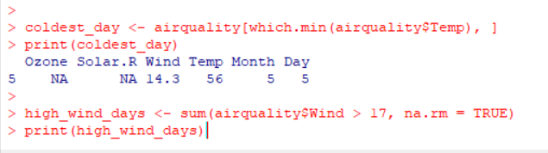

**8. Melt and cast airquality dataset**

**Output:**

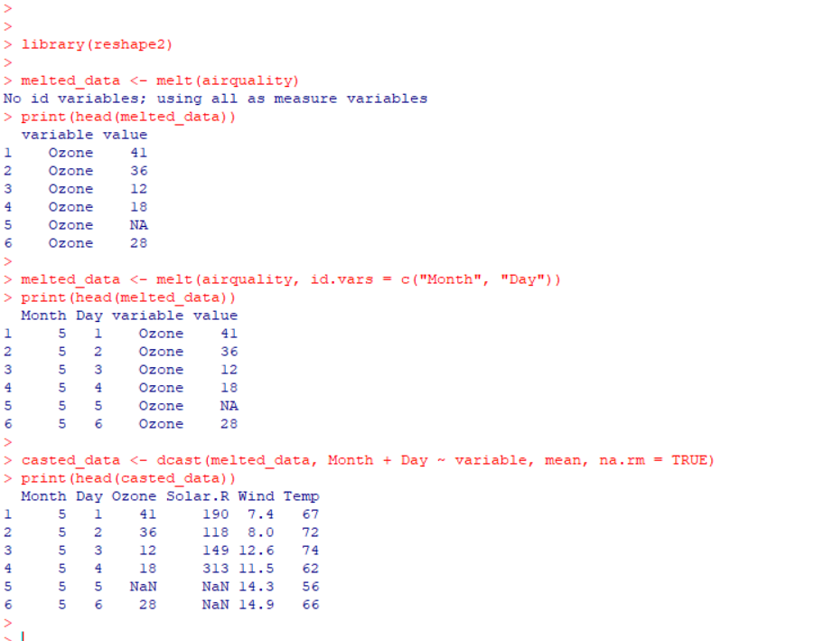

**9. Handle missing values and perform regression on**Ozone**vs**Solar.R

Output:

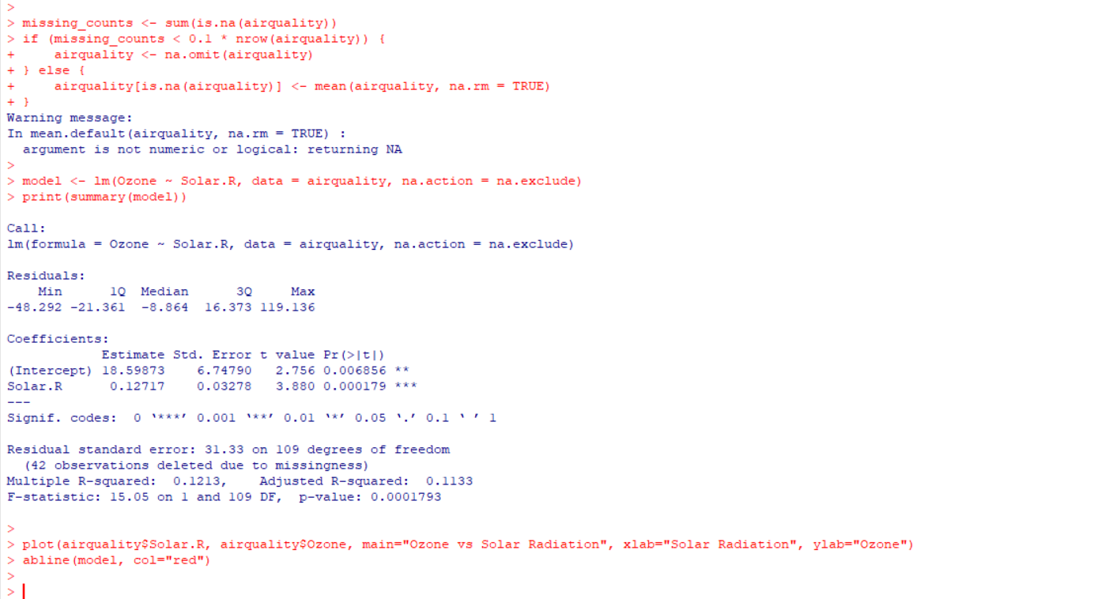

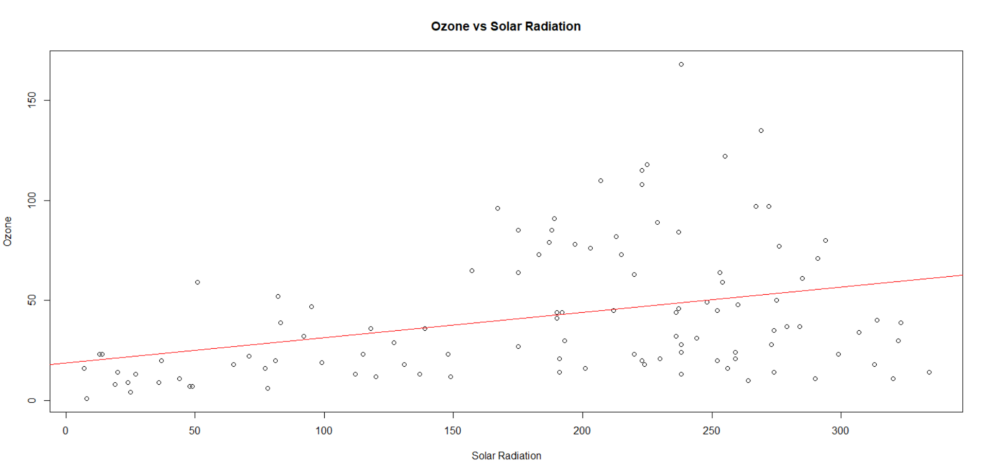

**10. Explore**USArrests**dataset**

Output:

